DAMAGED/WORN LOAD RESTRAINTS
Number: 136
Date:

Background
On 24 April, an FPC Officer was checking contractor loads when it was identified that two straps on the load had sustained damage. The driver immediately replaced the damaged straps.
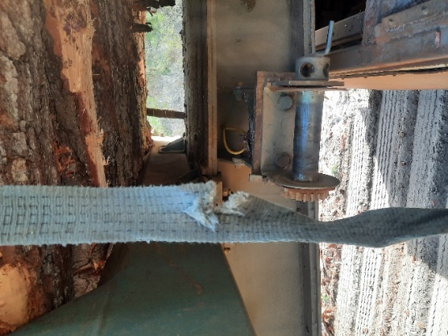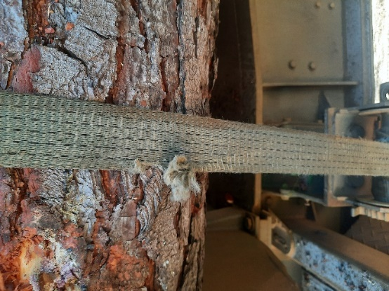
Key Points
- All straps should be checked regularly for damage and replaced as required.
- Checking of straps should form part of a driver’s prestart check.
- Damage to straps impacts the integrity of this safety feature, increasing the potential for load shift, rollover or loss of load which has the potential to cause serious injury or a fatality.
- The Load Restraint Guide (2018) lists the following points to look out for when using webbing:
  - Check there are no knots or twists in the webbing.
  - Check strapping is not attached to anchor points using knots.
  - Look out for webbing that appears furry because this indicates the webbing is worn and can lead to broken load-bearing fibres.
  - Look out for any damage caused by cuts and abrasions, particularly where the webbing contacts the load and any sharp metal edges.

